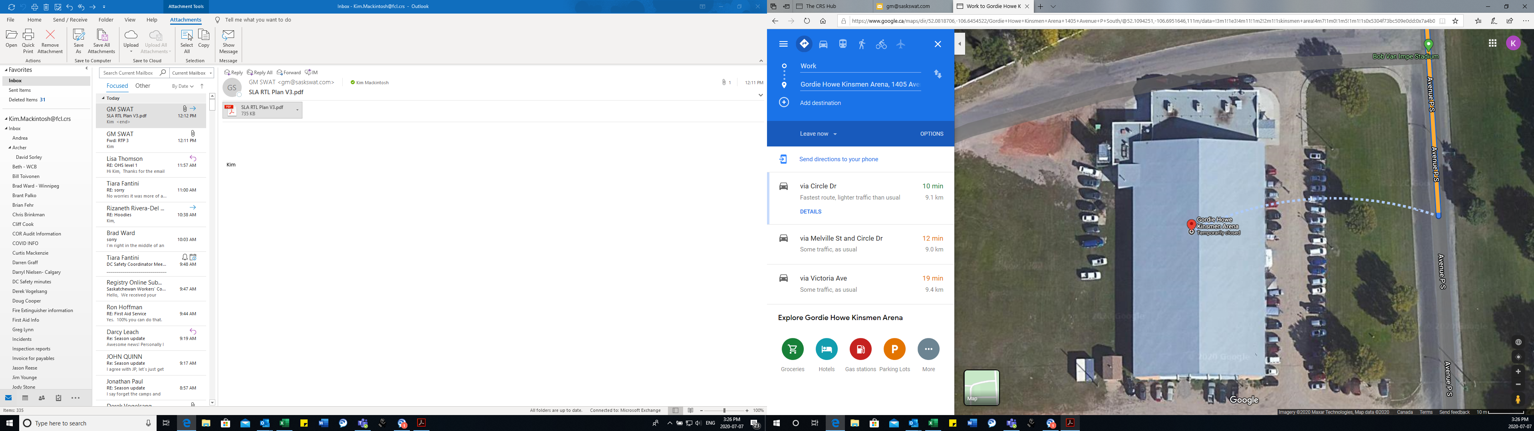

**PLAYER PICK UP**

**DROP OFF FOR PLAYERS**